Center of a Circle
# Source: AI Source: Provided by: [Data Path: Persons Table -> ID Column: 1, Name_En Column: Motasem Essam] -> From: [ChatGPT] on [7/25/2026]
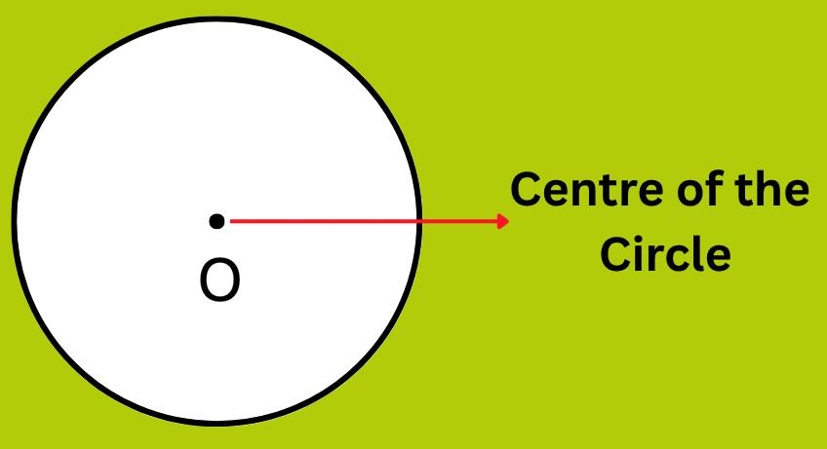
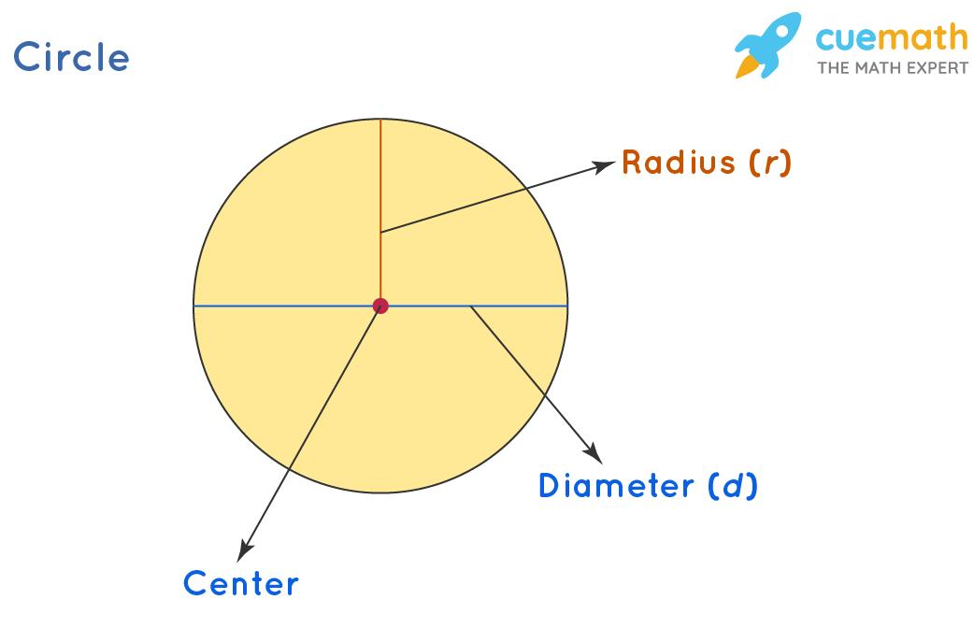
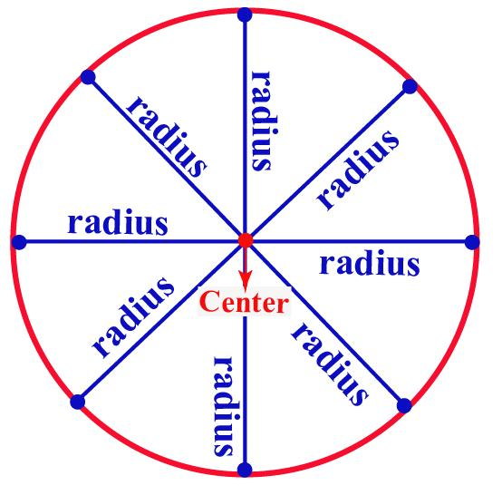
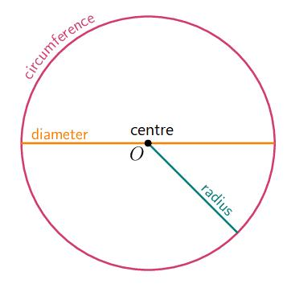
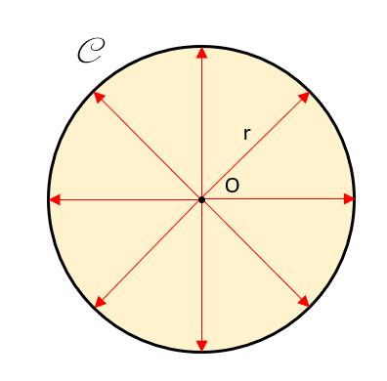

Definition
# Source: AI Source: Provided by: [Data Path: Persons Table -> ID Column: 1, Name_En Column: Motasem Essam] -> From: [ChatGPT] on [7/25/2026]
The center of a circle is the fixed point in the plane that is equidistant from every point on the circle's circumference.
The center is commonly represented by $O$.
If $O$is the center and $A$is any point on the circumference, then:
$$\boxed{OA=r}$$
for every point $A$on the circle.

Fundamental Concept
# Source: AI Source: Provided by: [Data Path: Persons Table -> ID Column: 1, Name_En Column: Motasem Essam] -> From: [ChatGPT] on [7/25/2026]
A circle is defined as the set of all points that are at the same distance from a fixed point.
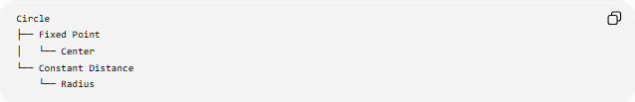
Circle
├── Fixed Point
│ └── Center
└── Constant Distance
└── Radius
Thus:
$$\boxed{\text{Circle}=\text{all points at distance }r\text{ from the center}}$$
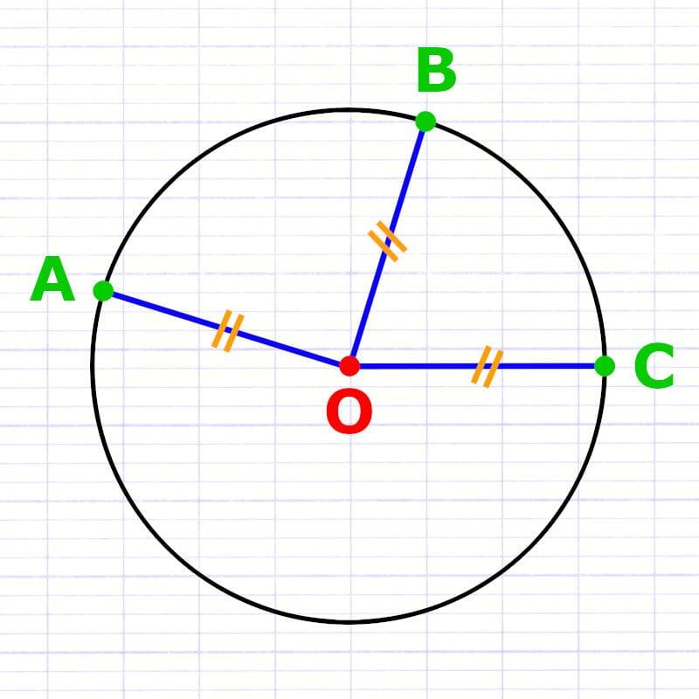
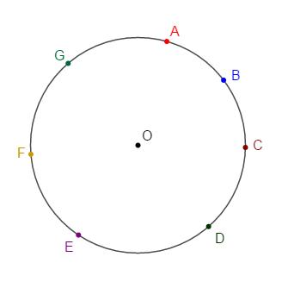
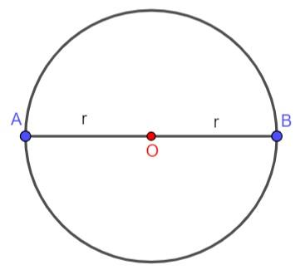

Main Properties
# Source: AI Source: Provided by: [Data Path: Persons Table -> ID Column: 1, Name_En Column: Motasem Essam] -> From: [ChatGPT] on [7/25/2026]
1. Equal Distance to the Circumference
Every point on the circumference is the same distance from the center.
$$OA=OB=OC=OD=r$$
2. Every Radius Starts at the Center
A radius connects the center to a point on the circumference.
$$\overset{‾}{OA}, \overset{‾}{OB}, \overset{‾}{OC}$$
are all radii.
3. Every Diameter Passes Through the Center
A diameter is a chord that passes through the center.
$$\boxed{d=2r}$$
4. The Center Is the Midpoint of Every Diameter
If $AB$is a diameter and $O$is the center:
$$\boxed{AO=OB}$$
5. The Center Is Unique
A circle has exactly one center.
Coordinate Representation
If the center of a circle is:
$$O\left(h , k\right)$$
and its radius is $r$, its equation is:
$$\boxed{{\left(x-h\right)}^{2}+{\left(y-k\right)}^{2}=r^{2}}$$
For a circle centered at the origin:
$$O\left(0 , 0\right)$$
the equation becomes:
$$\boxed{x^{2}+y^{2}=r^{2}}$$
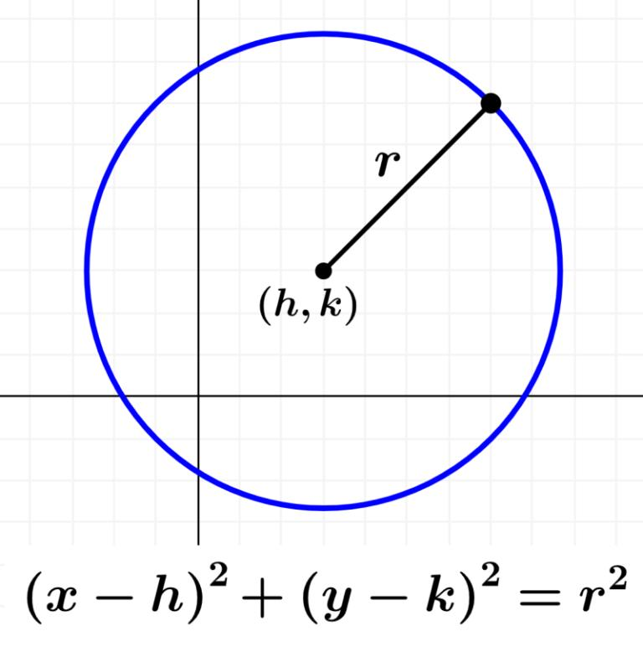
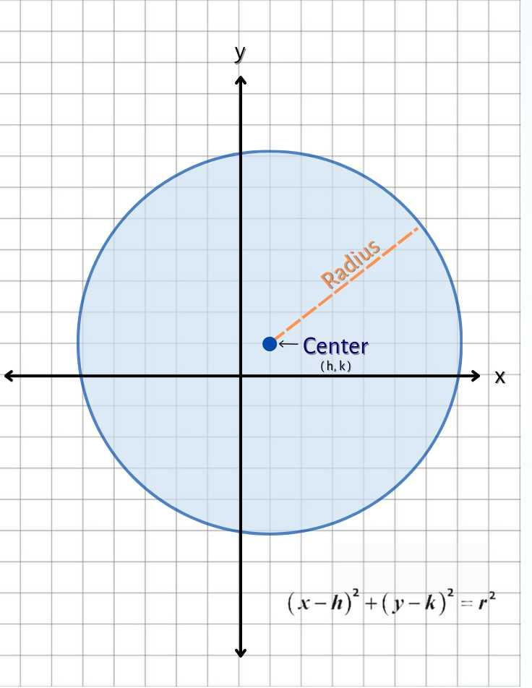
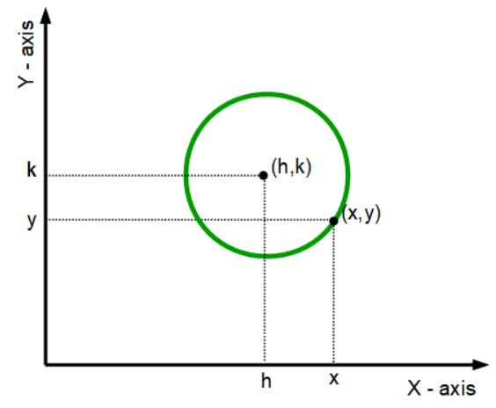
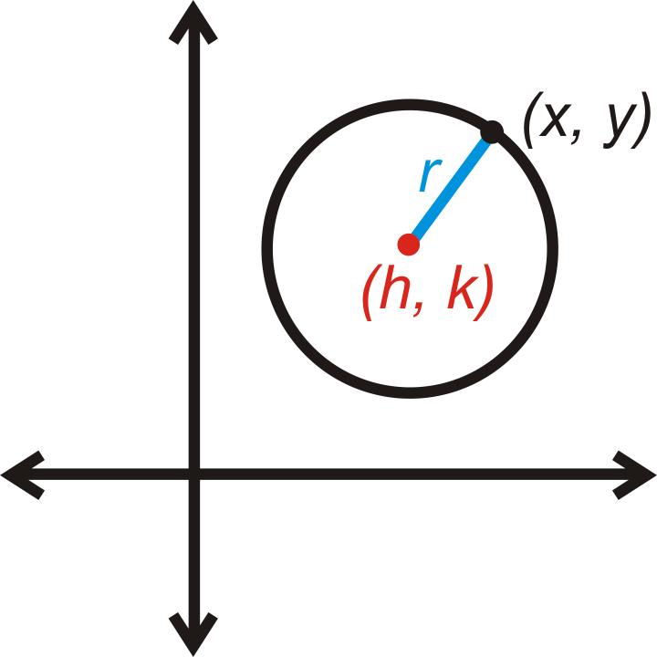
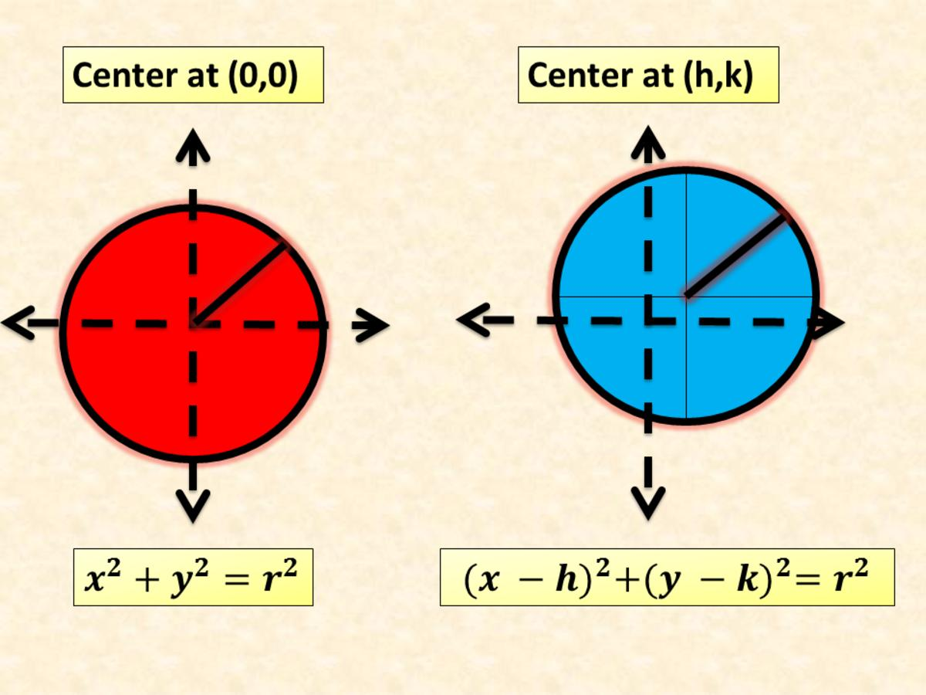

Center and Diameter
# Source: AI Source: Provided by: [Data Path: Persons Table -> ID Column: 1, Name_En Column: Motasem Essam] -> From: [ChatGPT] on [7/25/2026]
The center divides every diameter into two equal radii.
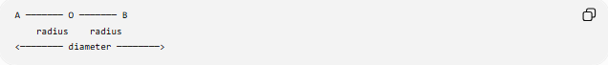
A ─────── O ─────── B
radius radius
<──────── diameter ────────>
Therefore:
$$AO=OB=r$$
and:
$$AB=2r$$

Center and Chords
# Source: AI Source: Provided by: [Data Path: Persons Table -> ID Column: 1, Name_En Column: Motasem Essam] -> From: [ChatGPT] on [7/25/2026]
The center also determines important relationships with chords.
If a perpendicular from the center meets a chord, it bisects that chord.
If:
$$OM⊥AB$$
then:
$$\boxed{AM=MB}$$
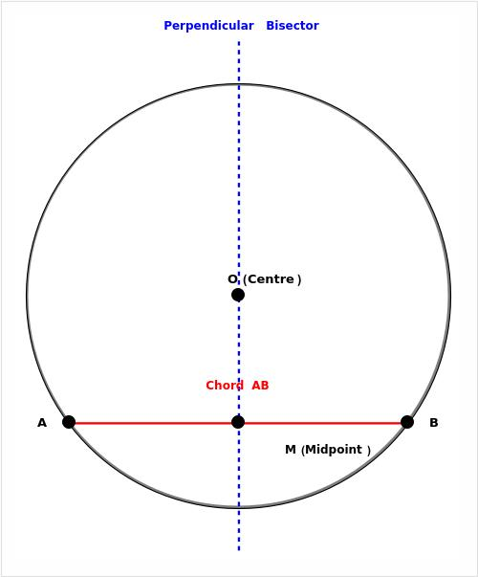
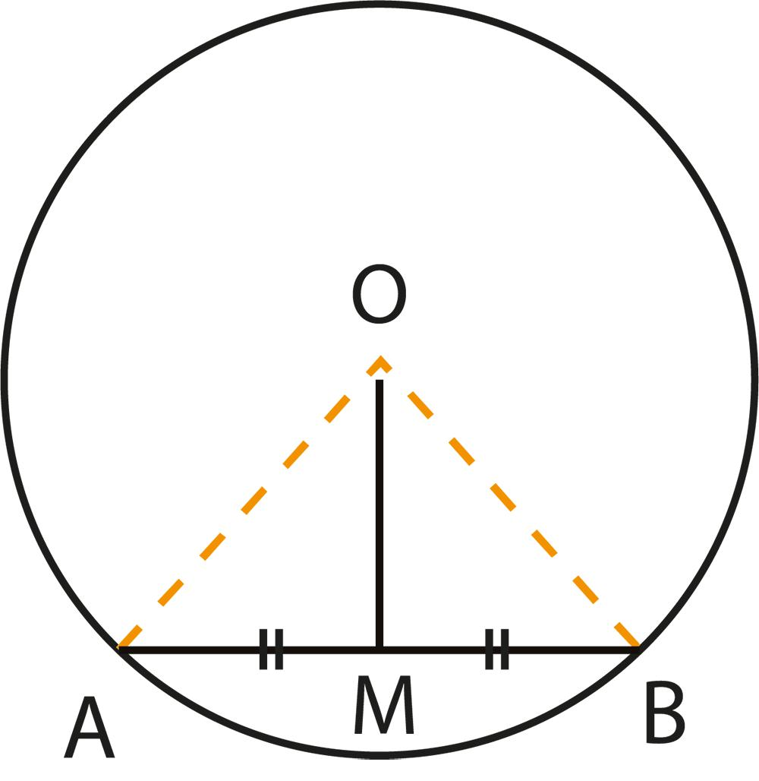
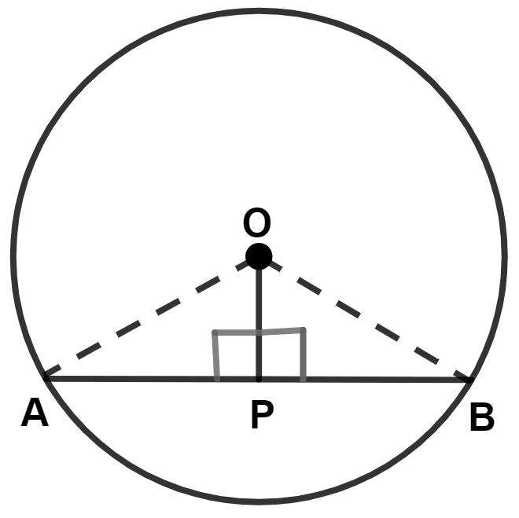
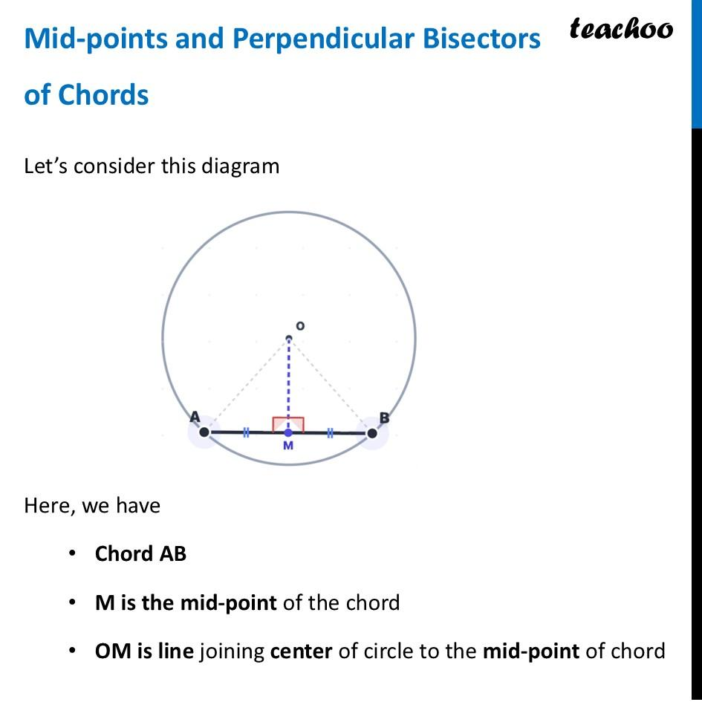
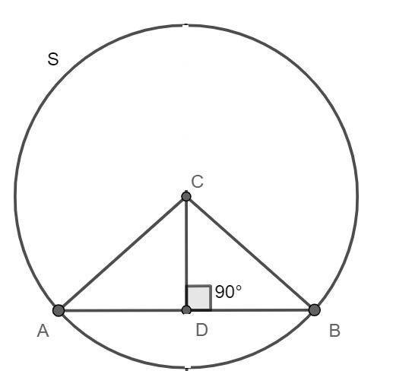

Center and Symmetry
# Source: AI Source: Provided by: [Data Path: Persons Table -> ID Column: 1, Name_En Column: Motasem Essam] -> From: [ChatGPT] on [7/25/2026]
The center is the point around which a circle has:
- Infinite lines of reflection symmetry
- Infinite rotational symmetry
Every line passing through the center is a line of symmetry.
A rotation about the center through any angle maps the circle onto itself.

Center vs Other Circle Elements
# Source: AI Source: Provided by: [Data Path: Persons Table -> ID Column: 1, Name_En Column: Motasem Essam] -> From: [ChatGPT] on [7/25/2026]
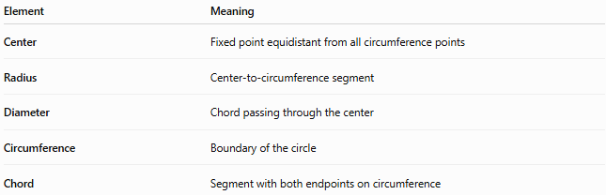
Element | Meaning
Center | Fixed point equidistant from all circumference points
Radius | Center-to-circumference segment
Diameter | Chord passing through the center
Circumference | Boundary of the circle
Chord | Segment with both endpoints on circumference

How to Locate the Center
# Source: AI Source: Provided by: [Data Path: Persons Table -> ID Column: 1, Name_En Column: Motasem Essam] -> From: [ChatGPT] on [7/25/2026]
The center of a circle can be found geometrically by drawing the perpendicular bisectors of two non-parallel chords.
Their intersection is the center.
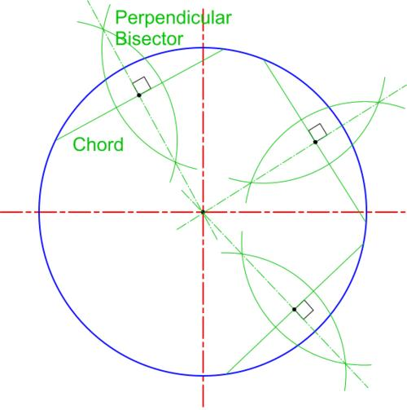
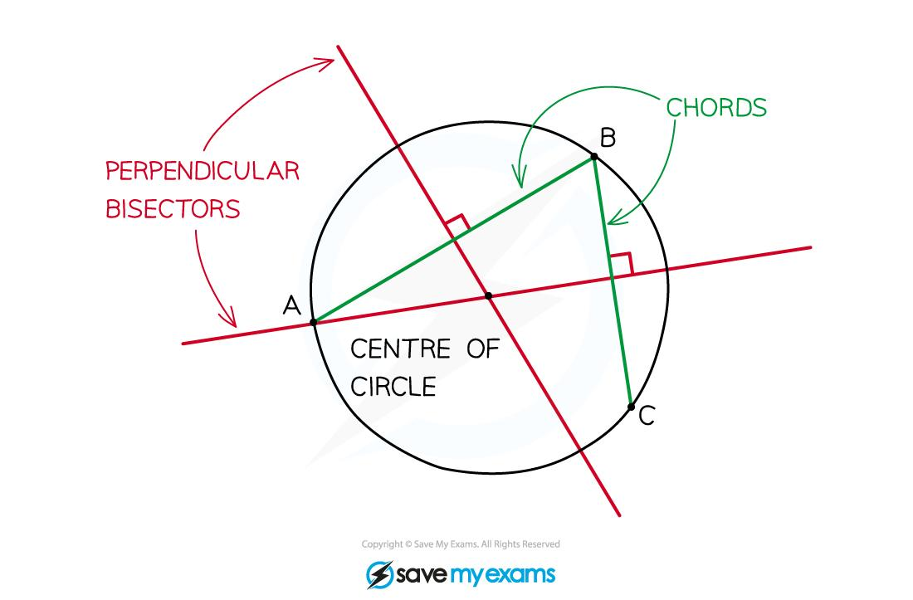
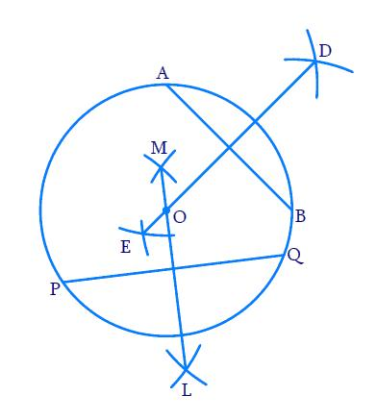
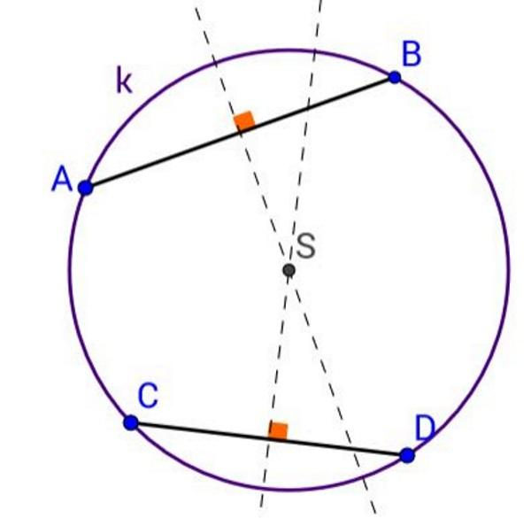
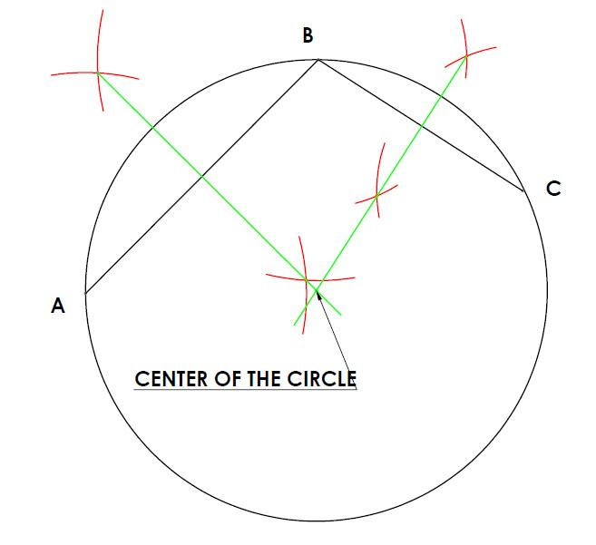

Related Concepts
# Source: AI Source: Provided by: [Data Path: Persons Table -> ID Column: 1, Name_En Column: Motasem Essam] -> From: [ChatGPT] on [7/25/2026]
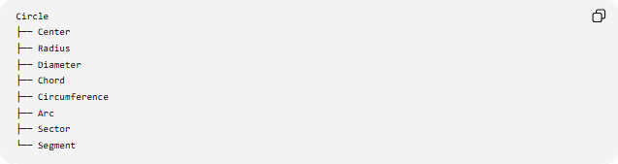
Circle
├── Center
├── Radius
├── Diameter
├── Chord
├── Circumference
├── Arc
├── Sector
└── Segment

Key Points
# Source: AI Source: Provided by: [Data Path: Persons Table -> ID Column: 1, Name_En Column: Motasem Essam] -> From: [ChatGPT] on [7/25/2026]
- The center is the fixed point of a circle.
- Every point on the circumference is equally distant from it.
- That constant distance is the radius.
- Every diameter passes through the center.
- The center is the midpoint of every diameter.
- A circle has exactly one center.
$$\boxed{OA=OB=OC=r}$$

Conclusion
# Source: AI Source: Provided by: [Data Path: Persons Table -> ID Column: 1, Name_En Column: Motasem Essam] -> From: [ChatGPT] on [7/25/2026]
The center of a circle is its fundamental reference point. It determines the circle's position and, together with the radius, completely defines the circle.
$$\boxed{\text{Circle}=\left\{P: OP=r\right\}}$$

